**Expression of Interest**

***My Backyard***

**St. Andrew’s Hospital x UniSQ School of Creative Arts**

**Exhibition Program 2024**

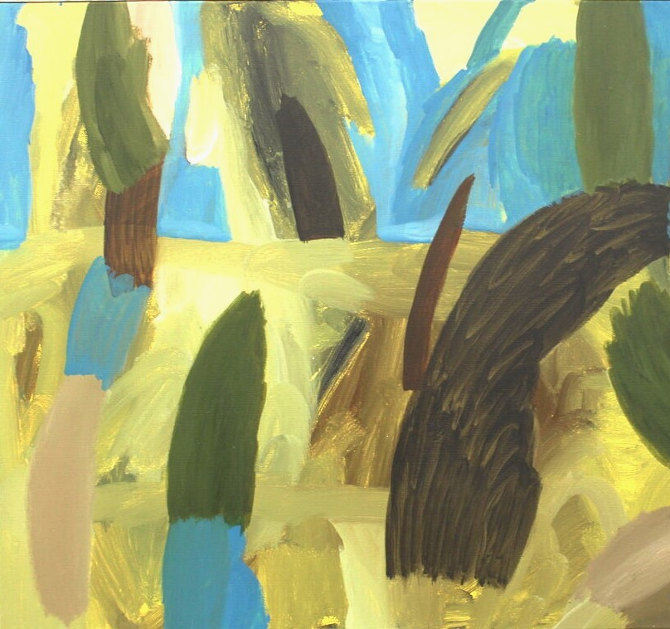

David Usher, *After the Fields,* 2020, oil on canvas, 80 x 63cm

**Exhibition Overview:**

*My Backyard* is the 3rd exhibition in the UniSQ School of Creative Arts x St Andrew’s Hospital exhibition series. Established in February 2023 and held on-site at St Andrew’s Hospital, Toowoomba, these exhibitions stage creative interventions in a clinical space.

For *My Backyard,* artists are asked to consider their immediate surroundings and how these can be interpreted or represented visually. This may mean investigating notions of place, of the everyday, of simple beauty, of banal rituals, or of small adventures close to home.

**Site Overview:**

St. Andrew’s Hospital, Toowoomba provides the UniSQ School of Creative Arts and their staff, students, and alumni in providing exhibition spaces for artworks. The works are to be displayed in a hospital setting, including in high-traffic hallways. Most patients visiting St. Andrew’s are mature-age, and key audiences include but are not limited to patients, their families, and hospital staff.

**Project Requirements:**

* Proposed artworks will be for internal display, and should be mountable on a wall as the works will be presented along the hospital wall way’s (textured canvases and 3D mediums are acceptable as long as they can be mounted on the wall and do not obstruct centre of walkway/corridor)
* Artworks need to be ready-to-hang (e.g. framed works on paper, or works on stretched canvas with wire and D-rings)
* Artworks need to be suitable in content for public viewing
* Artworks are not covered by insurance, and although all care will be taken, the hospital cannot accept responsibility in the event of damage to the work.
* Works can be rotated with similar alternatives, but will be on display for a period of 3 months (or as agreed between the artist and the hospital)
* The artist or a nominated representative will be responsible for the delivery and collection of artworks (in most cases, to and from UniSQ A Block)
* Images of proposed works will be provided to the hospital prior to installation
* UniSQ staff and volunteers will be responsible for the installation of artworks
* If the work is for sale, artists will handle sales independently. The artwork didactic may include a link or QR code linked to the artist’s website and/or email where they can be contacted directly and where further information may be sought. No commission on sales will be taken.

***My Backyard:* Important information**

* Expressions of Interest are due by **5pm 2nd February 2024**.
* Selected artworks will need to be delivered to UniSQ A Block, Toowoomba Campus **by Wednesday 14th February 2024.**
* Exhibition dates are to be confirmed (February to July 2024).
* Artists will have two (2) weeks to collect their work/s after the exhibition has concluded
* Please include your answers to the form attached, as well as images of your artwork.
* **Given the number of artists for this exhibition up to 3 artworks** per person can be submitted for each round.

**Please submit EOI to Rhi** via email on: [Rhiannan.Johnson@unisq.edu.au](mailto:Rhiannan.Johnson@unisq.edu.au)

**Expression of Interest**

St. Andrew’s Hospital – *My Backyard*

UniSQ School of Creative Arts Exhibition Program 2024

**Artist Details:**

Name:

Relationship to UniSQ (e.g. staff, student, alumni):

Phone:

Email:

Artist website (where applicable):

Artist Instagram (where applicable):

**Artwork Details:**

**Artwork 1**

Title:

Year:

Medium:

Dimensions:

Price:

**Artwork 2 (optional)**

Title:

Year:

Medium:

Dimensions:

Price:

**Artwork 3 (optional)**

Title:

Year:

Medium:

Dimensions:

Price: